**DAILY ONLINE ACTIVITIES SUMMARY**

|  |  |  |  |  |  |  |  |
| --- | --- | --- | --- | --- | --- | --- | --- |
| **Date:** | **19/06/2020** | | | | **Name:** | **Samrin Banu** | |
| **Sem & Sec** | **8th B** | | | | **USN:** | **4AL16C082** | |
| Online Test Summary | | | | | | | |
| **Subject** | | **SMS** | | | | | |
| **Max. Marks** | | **30** | | **Score** | | **22** | |
| Certification Course Summary | | | | | | | |
| **Course** | **GUVI** | | | | | | |
| **Certificate Provider** | | | **Python** | **Duration** | | | **26 hrs** |
| Coding Challenges | | | | | | | |
| **Problem Statement:**  1) Python rogram to find size of image | | | | | | | |
| **Status: Solved** | | | | | | | |
| **Uploaded the report in Github** | | | | **YES** | | | |
| **If yes Repository name** | | | | **Samrinbanu** | | | |
| **Uploaded the report in slack** | | | | **YES** | | | |

Online test detail:

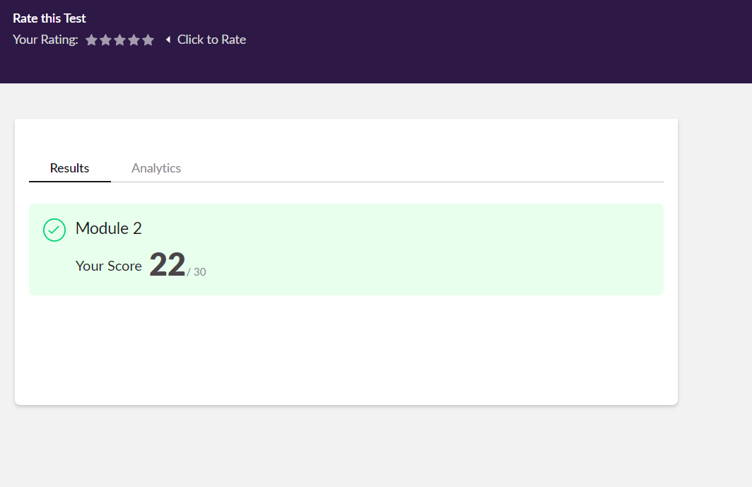

**Certifiction Course Details:**

# 

# CODE:

Program no:1

def jpeg_res(filename):

""""This function prints the resolution of the jpeg image file passed into it"""

# open image for reading in binary mode

with open(filename,'rb') as img_file:

# height of image (in 2 bytes) is at 164th position

img_file.seek(163)

# read the 2 bytes

a = img_file.read(2)

# calculate height

height = (a[0] << 8) + a[1]

# next 2 bytes is width

a = img_file.read(2)

# calculate width

width = (a[0] << 8) + a[1]

print("The resolution of the image is",width,"x",height)

jpeg_res("img1.jpg")